Woodbury Preserve Homeowner’s Assoc iation, Inc.

Thank you for your purchase of a Ryland/CalAtlantic Home! Attached you will find the Design Guidelines for the Woodbury Preserve Homeowner’s Association, Inc. (“Association”). The Association’s governing documents require that any modifications to the exterior of your home be approved by the Association.
These Design Guidelines are provided to you to help establish what modifications would generally be approved, however, each modification is reviewed on a case-by-case basis and based on your specific Lot. These guidelines are not intended to provide any preapproval and are subject to change by Ryland and/or the Association.

All approvals are subject to the following conditions:

- Change/improvement must not impede the flow of water in any drainage easement or swale.
- For any portion of construction in any easement, owner/applicant must hold the Association harmless for any costs associated with repair/replacement of change/improvement should the Association or local municipality or local utility need to enter such easement.
At the end of this document you will find the Association’s Request for Modification Form. This form should be completed for any modification and returned to your Association Manager. The completed form can be sent to:

Fieldstone Association Management 2675 Paces Ferry Road
Suite 125
Atlanta, GA 30339

A completed form must be submitted through the Association for all modifications. THE VERBAL APPROVAL OF ANY SALES AGENT, RYLAND EMPLOYEE, OR ASSOCIATION REPRESENTATIVE IS NOT SUFFICIENT. ALL MODIFICATION APPROVALS MUST BE IN WRITING.

When plans are required, they must be submitted with the form. A form is attached to these guidelines. Additional forms are available from the Association.
Again, congratulations on your new home and welcome to Woodbury Preserve!

Woodbury Preserve
HOMEOWNER DESIGN GUIDELINES
For Modification Review

October 2015

Table of Contents

- Definitions Overall Goal
Architectural Review Committee

- Application Information
Architectural Review Committee Enforcement Procedures

- Timeliness of Work All Required Permits

- Guideline1: Patios and Walkways
Guideline 2: Exterior Appearance, Decorative Objects, Front Porch Flower Pots Guideline 3: Garden Plots
Guideline 4: Play Equipment, Play Houses, and Tree Houses Guideline 5: Basketball Goals
Guideline 6: Private Pools, Landscape Ponds and Fountains Guideline 7: Fences, Privacy Screens
Guideline 8: Exterior Landscaping and Maintenance Guideline 9: Firewood
Guideline 10: Decks
Guideline 11: Exterior Building Alterations and Additions Guideline 12: Vehicles and Parking
Guideline 13: Satellite Dishes, Window Air Conditioners, and Window Fans Guideline 14: Addresses
Guideline 15: Signs in Yards
Guideline 16: Special Consideration For Lake Lots Guideline 17: Business Use

- Attachment: Application for Modifications

DEFINITIONS

The Protective Covenants contain design review authority and broad, general objectives of the community association to protect property values and integrity of the subdivision.
The Design Guidelines, which may be modified from time to time, have been developed to supplement and amplify the Covenants. The Design Guidelines serve two purposes:
    - To assist the homeowner, both in designing the proposed improvement and in determining how to apply for Approval;
    - To provide criteria for consistent decisions by The Association.

OVERALL GOAL

The overall goal of the Protective Covenants and Design Guidelines is to keep Marketplace Commons an attractive and desirable place in which to live.

B. | 1. | APPLICATION INFORMATION  The following exterior additions, improvements or modifications do not require a Request for
Modification Review Form to be submitted provided certain conditions are met: Patios (Guideline 1)
Exterior Lighting and Flag Poles (Guideline 2) Garden Plots (Guideline 3)
Children’s Wading Pools (Guideline 6) Ornamental Trees and Shrubbery (Guideline 8) Repainting with the same color (Guideline 11)
If you are unsure whether or not a Request for Modification Review Form needs to be turned in, please submit one!
 | 2. | A completed form must be submitted to the Association for all other types of modifications. The verbal approval of any sales agent, developer, Ryland Homes employee, or Association representative is NOT sufficient. All approvals must be in writing. When plans are required, they must be submitted with the form. A form is attached to these guidelines. Additional forms are available from the Association and the Marketplace Commons website.
 | 3. | The Protective Covenants state, “If the Association fails to approve or to disapprove submitted plans and specifications within thirty (30) days after the plans and specifications have been submitted to it, the foregoing will be deemed approved.” Any homeowner applying this rule must be able to prove in writing that any plans and specifications were received by the Association.

ASSOCIATION REVIEW - ENFORCEMENT PROCEDURES

- Violation of the Design Guidelines and/or the Protective Covenants may result in the following:

  - Suspension of the right to vote;
  - Suspension of the right to use the recreational facilities and common areas;
  - Recordation of notice of committee violation with the appropriate court;
  - Imposition of a fine on a per violation and/or per day basis;
  - Correction of the violation by the Association with all costs charged to the violator;
  - Filing a lien for all fines, attorney’s fees and costs to correct the violation.

TIMELINESS OF WORK

All work approved by Ryland/HOA Board of Directors shall be completed within three months of the approval date, unless otherwise approved. If the work is not performed in this timeframe, the work must be resubmitted for approval. Homeowners should submit a time-line of the work scheduled. Homeowners shall inform the Association upon completion of a project so that a final inspection may be performed.

ALL REQUIRED PERMITS

  - All homeowner Modification Request Forms that involve construction or alteration of a structure that requires a building permit from the local municipality(s) having jurisdiction must be submitted and reviewed for compliance with the Design Guidelines by the Association based only on the Design Guidelines, not the permitting requirements of the municipality nor any State or Federal governing agency. All required building permits must be granted by the local municipality having jurisdiction before submitting for association approval.

  - It is the responsibility of the homeowner to confirm if a building permit is required the local municipality for the requested structure. Ryland Homes and the Association/Board of Directors do not have the authority or the ability to inform homeowners if municipality requires a building permit.
  - The homeowner is fully responsible for obtaining the necessary permits as required by the governmental agencies having jurisdiction over the proposed improvement. The homeowner is solely responsible for compliance with the codes and ordinances of the governmental agencies having jurisdiction over the construction.

  - Ryland Homes, the Association and the Board of Directors shall not be held responsible for any modification or alteration constructed by or on the behalf of homeowners who do not obtain the proper permits. This is regardless of whether the structure is approved by the HOA, as the Association makes decisions based solely on the Design Guidelines.

  - Keep in mind that in the event a permit is successfully obtained from a local municipality or county, the Modification Request Form must be submitted, reviewed and approved before work can begin. A permit does not guarantee approval by Ryland/the Association/Board of Directors.

The contents of these guidelines, and any actions of Ryland or the Association, Board of Directors or its agents, are not intended to be, and should not be construed to be an approval of the adequacy, reasonableness, safety, structural integrity, or fitness for intended use of submitted plans, materials, or construction, nor ensuring compliance with building codes, zoning regulations or other governmental requirements. Neither the Association, the Board, nor member thereof shall be held liable for injury, damages or loss arising out of any approval or disapproval, construction or through such modification to a lot.

GUIDELINE NUMBER 1: PATIOS AND WALKWAYS

- Submission of a form for a patio is not required if:

  - The patio does not extend beyond the sidelines of the house and does not extend to within ten (10) feet of the side property lines; and
  - The patio does not exceed six (6) inches above ground level at any point; and

  - The existing drainage patterns are not altered in a manner that adversely impacts any adjacent properties and the drainage of the patio is directed to the homeowner’s own property and properly dispersed.

- Submission of a form for a walkway is not required if the walkway is located in the rear yard
and:

  - Is no closer than ten (10) feet from the side property lines; and

  - The walkway does not exceed four (4) inches above ground level at any point; and

  - If the existing drainage patterns are not altered in a manner that adversely impacts any adjacent properties and the drainage of the sidewalk is directed to the homeowner’s own property and properly dispersed; and

  - If the width of the sidewalk does not exceed 4’-0”.

  - A form must be submitted for a finish or texture other than a natural broom finish.

  - Is a stone or paver path

GUIDELINE NUMBER 2: EXTERIOR APPEARANCE, DECORATIVE OBJECTS, FRONT PORCH FLOWER POTS, LIGHTING, HOUSE NUMBERS, ETC.

Exterior Appearance - General

The preservation of the character of the exterior appearance of homeowner property is the primary purpose of the Design Guidelines. In making selections or decisions, homeowners should consider the following:
- A form must be submitted if you are repainting and considering any color change. Approval is not required to repaint in accordance with an original approved color scheme. Please review the other houses around you and select colors different from the house next door or across the street. See Guideline Number 11.

- Window treatments that are visible to the street should be made to blend with the exterior by using a white or off-white liner so that the vibrant colors or patterns you select for the interior do not clash with your exterior colors.
- A form for approval is not required for one (1) decorative object placed in the front or side yards or porch that is a natural color, does not exceed 18” in height and is located within 15’ of the boundary of the home. A form must be submitted for all other exterior DECORATIVE objects, both natural and manmade. Exterior DECORATIVE objects include items such as bird baths, birdhouses, wagon wheels, sculptures, statues, fountains, pools, antennas, free-standing poles of all types, flag poles, gazing balls and yard art, and items attached to approved structures and visible from any Marketplace Commons street.
- Objects will be evaluated on criteria such as location, proportions, color and appropriateness to the surrounding environment.
- Except as provided below, a form must be submitted for all exterior lights or light fixtures not included as part of the original structure. However, a form is not required for landscape lights that meet the following criteria:
  - Light fixture does not exceed twelve (12) inches in height; and

  - The number of light fixtures does not exceed ten (10); and

  - All lighting does not exceed 20 watts rating (low voltage lighting), should be white or clear, non-glare, and shall be directed towards the homeowner’s house and landscaping only.

  - All light fixtures must be black. A form will be required for any finish other than black.

GUIDELINE NUMBER 2: EXTERIOR APPEARANCE, DECORATIVE OBJECTS, FRONT PORCH FLOWER POTS,
LIGHTING, HOUSE NUMBERS, ETC. - Continued

- A form is not required to be submitted for a single flag pole staff attached to a portion of a house to display the official state flag of Georgia or the official flag of the United States of America. Such flags may not exceed 3 x 5 FT in size. These poles may also be used for the temporary display of flags related to schools, colleges, universities, or flags such as might be used for holiday seasons. Temporary flag displays shall be limited to the season. See Figure 1.
- Front doors and entry area decorations must be in keeping with the style and colors of the house. Live plants and live flowers in pots must always be neat and healthy. Neatly maintained front porch flower pots, containing evergreens/flowers, do not require submission of a form.
- House numbers shall only be displayed on the mailbox.

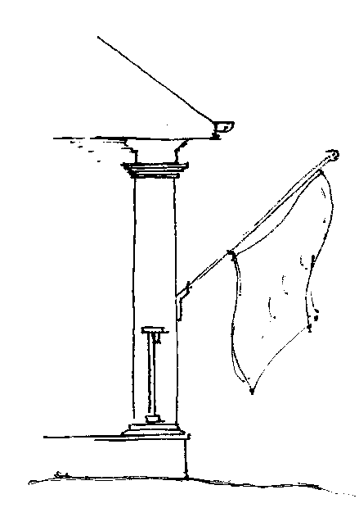
3x5 Flag Mounted to Column

Fig. 1
3x5 Flag
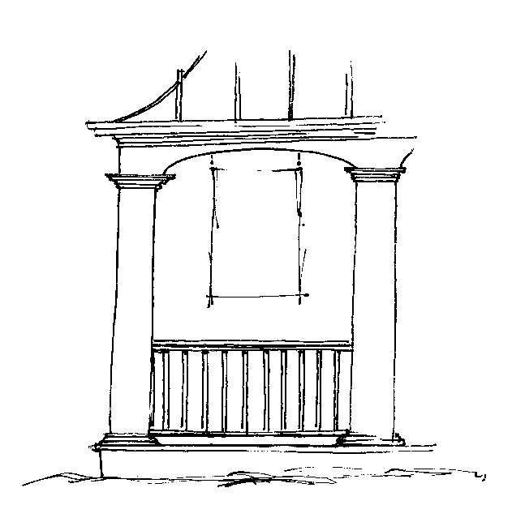
Mounted between columns

GUIDELINE NUMBER 3: GARDEN PLOTS

- A form must be submitted for garden plots unless all of the following conditions are met:

  - The plot is located behind the rear line of the house and ten (10) feet from the side property line; and
  - The plantings are less than 6’ in height; and

  - The plot must be properly maintained per the community standards; and

  - The plot does not alter the existing drainage patterns in a manner that adversely impacts any adjoining property; and

  - The maximum area is 10’x10’; and

  - Garden must be screened from any street view. See Figure 2.

- All garden plots must be located behind the rear line of the house. All other proposed locations will be considered on an individual basis when a form is submitted.
- Garden plots are planting areas or beds that contain anything other than ornamental plants, such as vegetables, herbs, peanuts, watermelons and the like. Seasonal plants which exceed heights of six (6) feet or more in growth need a form submitted.
- Garden plots shall be cleared of dead plants and overgrowth after the growing season.

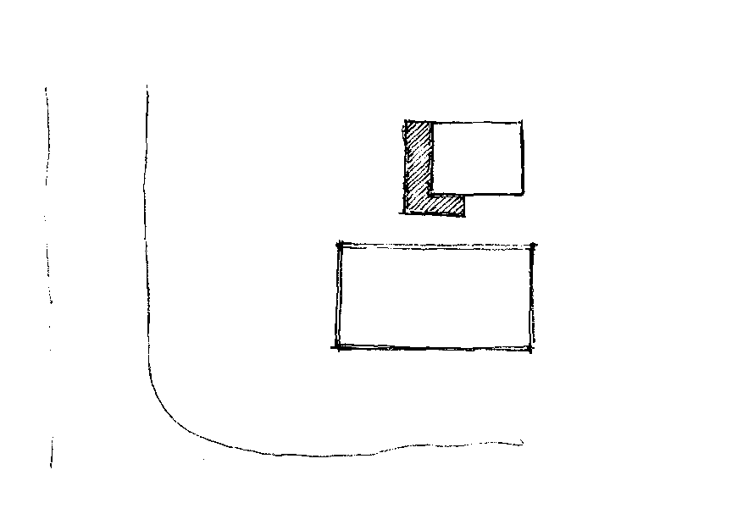
Ornamental planting
Or shrubs to screen view.
Garden Plot
Fig. 2

GUIDELINE NUMBER 4: PLAY EQUIPMENT, PLAY HOUSES, AND TREE HOUSES

- A form is required to be submitted for all play equipment. The following guidelines apply:

  - In the rear yard; and

  - Within the extended sidelines of the house, with the placement in the middle 1/3 of rear; and
  - Within the screened fenced area of the yard, if yard is fenced; and

  - Such that it will have a minimum visual impact on adjacent properties as determined by the Architectural Review Committee (“ARC”); and

  - The play equipment or associated landscaping materials do not alter the existing drainage patterns in a manner that adversely impacts any adjoining property; and
  - Trampolines must be screened from any street view.

- Metal play equipment, other than trampolines, is NOT permitted, exclusive of wearing surfaces (slide poles, climbing rungs, swing seats, etc.). Bright colors in general are not allowed. Play equipment should be constructed of natural materials and colors. All colors should be natural earth tones such as dark green, tans and browns. All play equipment, play houses and tree houses must be properly maintained.
- A baseball backstop or similar item is not play equipment and must comply with the fence guidelines.
- A form must be submitted for all play houses and tree houses.

- Playhouses and tree houses must be located where they will have a minimum visual impact on adjacent properties. In most cases, material used must match existing materials of the house and the playhouse or tree house is not to exceed sixty four (64) square feet and/or 12 feet in total height.

- Appropriate evergreen landscaping shall be used to screen around the playhouse.

- Playhouses and tree houses will not be permitted in common areas.

GUIDELINE NUMBER 5: BASKETBALL GOALS

- Basketball goals on individual Lots are discouraged due to the proximity of houses in the community and the potential for disturbing the peaceful enjoyment of neighbors. In-ground basketball goals are permitted on a conditional basis. See Figure 3. A form must be submitted and will be considered if all of the following requirements are met:

  - The post is painted black;

  - A drawing accompanies the form showing the proposed location.

  - The backboard is clear.

  - Permanent goal is located no further forward than the front line of the house.

- Owners must maintain the appearance of the pole and goal at all times.

- If freestanding or portable, goal must be kept close to the house except when in use.

- No goals may be attached to the exterior of the house, deck, etc.

Target Box
Fig. 3

Clear Backboard Black Pole

GUIDELINE NUMBER 6: PRIVATE POOLS, LANDSCAPE PONDS and FOUNTAINS

- A form is not required to be submitted for children’s portable wading pools (those that can be emptied on a nightly basis) that do not exceed eighteen (18) inches in depth and whose surface area does not exceed eight (8) feet in diameter.

- Above ground pools are prohibited.

- A form must be submitted for ALL in-ground pools and ponds:

  - All forms for a pool addition shall be submitted with a drawing of the property that accurately depicts the location of the house, property lines, building setbacks, decks, easements and any other elements that may restrict the location of the proposed pool. See Figure 4. The drawing shall be prepared to a scale of 1”= 10’. The drawing shall dimensionally depict the proposed location of the pool and pool deck, pool equipment and any other related improvements. The proposed drainage plan shall be clearly indicated including all existing drainage conditions. All proposed materials and colors should be indicated on the drawing. The drawing shall indicate the location and type of silt fence to be installed and maintained during construction. Existing trees and other landscaping that are to be removed to accommodate the proposed pool improvements shall be marked with ribbon for review by the ARC prior to removal.
  - The appearance and detailing of all retaining walls must be consistent with the architectural character of the house. Retaining walls shall not exceed 4’-0” in height. Walls exceeding 4’0” in height will require an engineered drawing and building permit. All retaining walls shall be located a minimum of 3’-0” clear of any property line to allow for drainage and the maintenance of the wall. Some terracing may be acceptable.

  - Fencing for lots with pools and spas must comply with the fence guidelines.

  - Maximum pool area is eight hundred (800) square feet.

  - Glaring light sources, which can be seen from neighboring lots, shall not be used.

  - The pool area shall be enhanced with landscaping and all pool equipment shall be screened with evergreen landscaping.
  - Pool equipment shall be located a minimum of 15’-0” from any adjacent property and shall be behind the rear plane of the house.
  - Dirt excavated shall not be stored on the lot longer than one calendar week. All stored excavated dirt shall be immediately covered with straw to prevent erosion and be provided with appropriate erosion control mechanisms.
  - A construction timetable is required, including a completion date.

GUIDELINE NUMBER 6: PRIVATE POOLS and LANDSCAPE PONDS - Continued

Landscape Screening
Pool & Spa Area Fence (refer to fence guidelines) Property Line

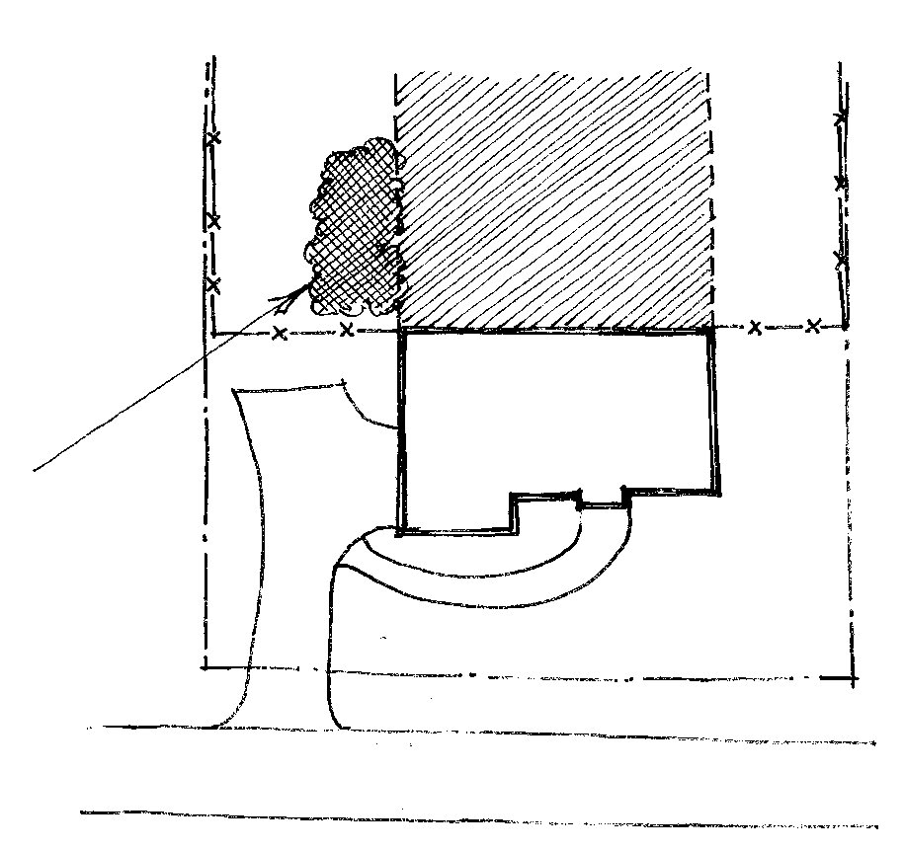
drive

street
House

Fig. 4

GUIDELINE NUMBER 7: FENCES, PRIVACY SCREENS – See Figure 5.

- The original design concept of Woodbury Preserve promotes a feeling of open space; therefore, fencing is not generally encouraged. A form must be submitted for ALL fencing.
- Chain link and vinyl fences are prohibited. No wire fences, chicken wire, or welded wire fences are permitted.

- No double fencing is permitted.

- All forms must include the following information:

  - Picture or drawing of fence type.

  - Dimensions:

    - The height shall not exceed six (6) feet.
    - For black metal fences, the height shall not be less than five (5) feet.
    - The maximum span between posts shall be ten (10) feet.
    - For wood fences the minimum post size shall be 4”x 4” and the maximum shall not exceed 6”x 6”.
    - For wood fences the crossbeams shall consist of either two 2”x 6” rails or three 2”x 4” rails per section as a minimum.
    - Crossbeam structure must face inside towards the yard.
  - Color: Unless approved by the ARC, the fence stain shall be clear sealant. Painting of fences is not permitted.
  - Site Plan: A site plan drawing denoting the location of the fence must accompany the form. Fences shall not be located closer to any street than the rear corner of the home except for the following conditions that will be considered on a case by case basis:
    - On corner lots, fence shall not be closer to any street than 36’ from the back of the curb.

    - If the “rear” door of a house (basement, crawl space, or main level) or the air conditioner unit(s) is on the side of the house within six (6) feet of the “rear” of the house, fence construction will be allowed to begin at the door or the air conditioner unit(s) so that the door or air conditioner unit(s) is within the fenced-in area.

- Dog Runs are not permitted.

- Each homeowner must maintain the fences located on his/her respective property regardless of origin of construction or location.

GUIDELINE NUMBER 7: FENCES

- Fences shall tie into any existing fence located on an adjacent Lot. The types of fences located on adjacent Lots shall be considered in the approval process. For example, if an adjacent Lot has wooden fencing, fencing that matches the type and material of such adjacent Lot shall be considered.
- Illustrations of the approved fencing are shown in Figure 6. Before selecting the desired fence style refer to these guidelines. For fence #1 and fence #2, black welded wire mesh “hog wire” is optional on the inside face.

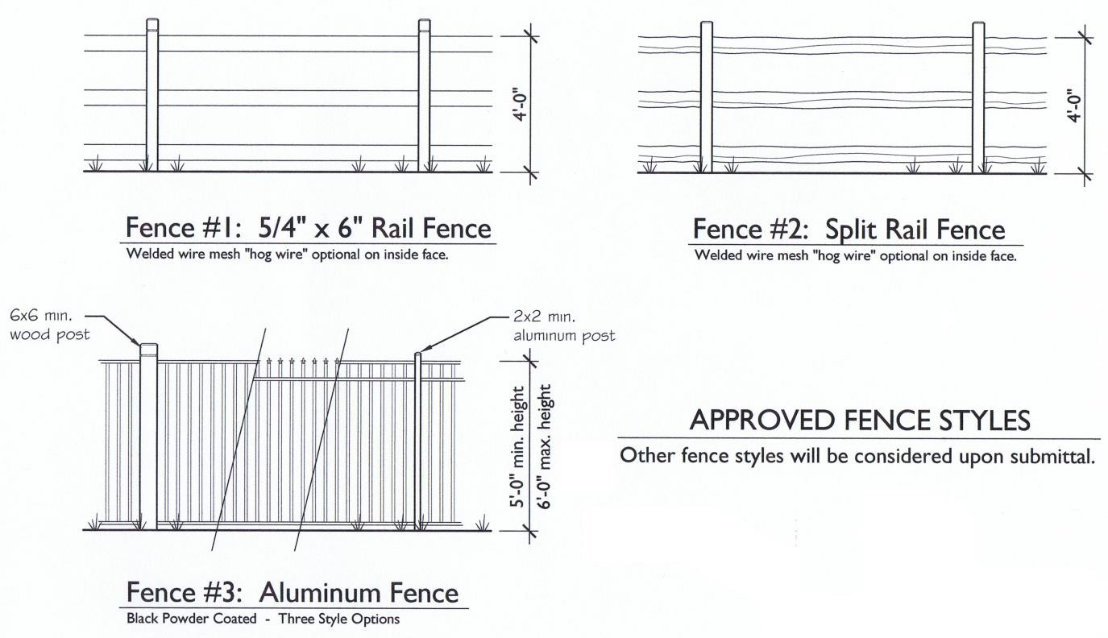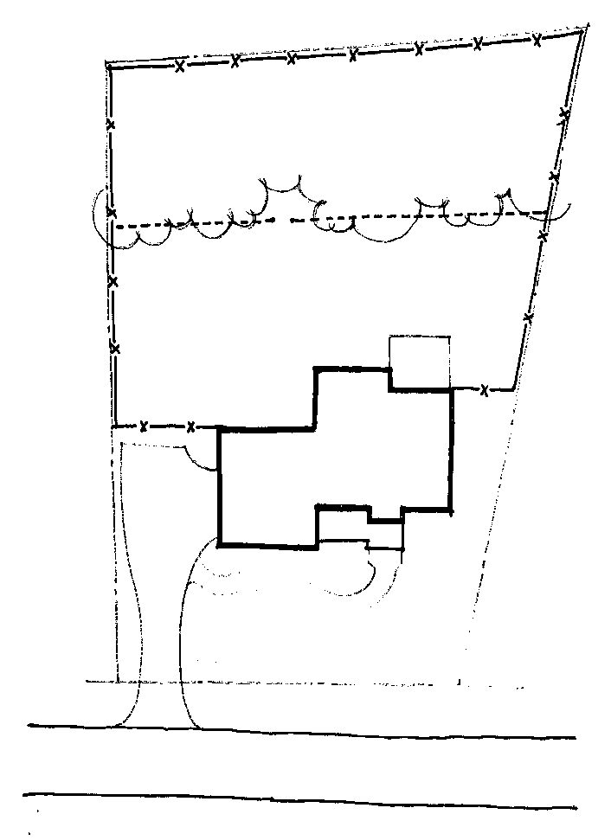
Property Line
Fence
Tree Line
Property Line Fence
Gate
Optional Rear
Fence Line Property Line Fence
House
Drive
Fig. 5
street
Fig. 6

GUIDELINE NUMBER 8: EXTERIOR LANDSCAPING AND MAINTENANCE

- A form is not required to be submitted for ornamental trees and shrubbery provided that all of the following guidelines are met:
  - Tree plantings (row or cluster styles) are not permitted from the front line of the house to the street. In the case of corner lots, trees (row or cluster style) are not permitted from the front corner of the house on the adjacent lot(s) to the street.
  - However, row or cluster tree plantings are permitted from the front corner of the house to the rear corner of the property line. Staggered tree planting is preferred over rows. Hardwood trees should be located a minimum of ten (10) feet from property lines. Evergreen trees shall be located a minimum of five (5) feet from adjacent property lines.

- All landscaping beds must be covered with a suitable covering such as natural pine straw, chopped pine bark mulch, or wood shavings of natural earth tones. Black and red mulch are not permitted. Rock is only permitted in natural colors of tan, beige and gray. White rock is not permitted.
- Landscaping should relate to the existing terrain and natural features of the lot, utilizing plant materials in keeping with the horticultural appearance of the community. Approved grass types for front lawns are Bermuda, Fescue or Zoysia. The amount and character of the landscaping must conform to the precedent set forth in the Marketplace Commons Community.
- Each owner is responsible for removal of debris, clippings, etc. from the property line to the center of the street. All planting areas should be properly maintained at all times, and, after the first frost, all affected material should be removed. At the end of the growing season, all dead plants should be removed. Bare earth must be covered with natural pine straw or earth tone mulch to prevent soil erosion.
- The preferred landscape edging is a neat four (4) to six (6) inch deep trench. All standard bed edging: brick edging that match the brick of the house, stone, or concrete must be approved by the ARC. Landscape bed edgings must be buried so that no more than one (1) inch extends above the ground, and must be of uniform type. Permanent masonry must be approved. Wood or decorative plastic is not permitted. Black polypropylene edging does not require approval provided it is installed properly, i.e. only the rounded edge is above ground level.

- Retaining Walls in the front of a home should be brick, stone, or split-face concrete block to match the house. Landscape timber walls will be allowed in rear and side yards on a case by case basis. All retaining walls must be submitted to the ARC for approval.

GUIDELINE NUMBER 8: EXTERIOR LANDSCAPING AND MAINTENANCE - Continued

- Each homeowner shall keep his/her lot and all improvements thereon in good order and repair including, but not limited to, seeding, watering, regular mowing, edging, the pruning and cutting of all trees, shrubbery and weed control; homeowners should also maintain the painting or other appropriate external care of all structures and removal of dead trees. This should be done in a manner and with such frequency as is consistent with good property management and the precedent set forth in the Marketplace Commons Community.
- Outdoor storage of garden tools and hoses must be screened from view and be kept behind shrubs. Any tools or items stored under a back deck or porch must also be screened from view.
- Outdoor storage of garbage cans and trash bins is discouraged. Containers stored outside must be screened from view by natural landscaping (no lattice).
- All debris, clippings, etc. must be properly removed from lawns, driveways, sidewalks, streets, etc. Hosing, raking or blowing materials into the streets and into the storm water management system is not permitted.

GUIDELINE NUMBER 9: FIREWOOD

- Firewood piles must be maintained in good order and must generally be located within the sidelines of the house and in the rear yard in order to preserve the open space vistas. The size of a firewood pile may not exceed 4’ wide, 4’ high and 6’ long. See Figure 7.
- Firewood pile coverings are allowed only if the cover is an earth tone color and the firewood pile is screened from the view of the street. For example, a tarp-covered firewood pile may be located under a deck and have shrubs planted around it.

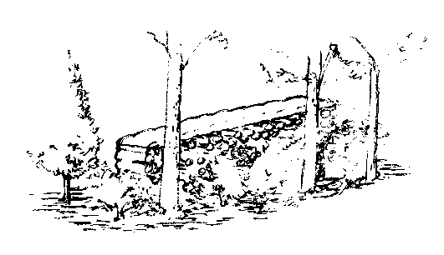
Earth-tone Tarp
Fig. 7
Wood pile set in natural areas & screened with landscaping

GUIDELINE NUMBER: 10 DECKS

- A form must be submitted for ALL decks.

- The form must include the following:

  - A site plan denoting location, dimensions, materials and color.

  - In most cases, the deck may not protrude past the sides of the house and must be located in the rear of the house.
  - Materials must be cedar, cypress, or Number 2 grade or better pressure treated pine (other material will be considered). Composite material is allowed but is subject to color approval by the Association.

  - The deck must be natural or stained a natural wood color. All other stain colors must receive Association approval.
  - Specific approval of the ARC is required for painting a deck to match the trim color on the house and will be limited to decks constructed with detailed railings and columns.
- Vertical supports for wood decks must be a minimum of 6”x 6” wood posts that match the color of the deck or metal poles. Metal poles shall be boxed in so as to appear to be 6”x 6” wood posts.
- A rail design shall be submitted with the site plan and form indicating the picket and rail materials and design. A brochure may indicate the design if a prefabricated design is used; otherwise, the design should be drawn to scale to indicate the design.
- The following, without limitation, will be reviewed: location, size conformity with design of the house, relationship to neighboring dwellings, proposed use and screening components/features.
- Homeowners are advised that local municipalities having jurisdiction will require a building permit for construction of a deck.

Property Line
Extents of
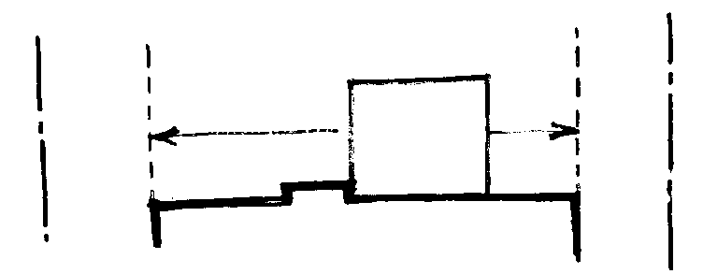
Deck Expansion Property Line
15’
Min.
exist.
deck
House

Fig. 8

GUIDELINE NUMBER 11: EXTERIOR BUILDING ALTERATIONS AND ADDITIONS

- A form must be submitted for all exterior building alterations and additions. Building alterations include, but are not limited to, storm doors and windows, construction of driveways, garages, porches and room additions to the house. Exhibit A is an example of the plan details that should be submitted with the Application for Modification. Repainting requires prior written approval only if the color is changed from the original color of the house.

- The original architectural character or theme of any house must be consistent for all proposed additions and alterations to the structure. Once the character is established, whether it is traditional, contemporary, etc., no change may alter that character.

- A form requesting a paint color change requires the following information:

  - Paint sample color used in or approved for the Marketplace Commons Community; and

  - Area of house to be repainted; and

  - Photograph of the house to be painted and the houses on both sides (in most cases, adjacent houses should not be painted the same color).
- Storm doors must be made of anodized bronze or anodized aluminum with baked enamel painted finish that matches the front door of the house. Storm door windows must be of solid glass with no decorative or protective metal workings. A form must be submitted for all storm doors (on the front, side, or rear of the house) and contain the following information: See Figure 9.

  - Picture or drawing of the door on which storm door will be installed; and

  - Picture depicting style of storm door to be installed; and

  - Color.

- Storm windows must be made of anodized bronze or anodized aluminum with baked enamel finish compatible with the primary and trim colors of the house. Storm windows must be of solid glass with no decorative or protective metal workings. A form must be submitted and contain the following information:

  - Storm windows must comply with window to be covered; and

  - Picture or drawing of the window; and

  - Picture depicting style of storm window to be installed; and

  - Color.

GUIDELINE NUMBER 11: EXTERIOR BUILDING ALTERATIONS AND ADDITIONS - Continued

Glass (no Decorative muntins
Door (painted
to match existing main door color)

Full View S torm Door
Fig. 9

- Decorative Windows such as stained glass, decorative glass, etched glass, or leaded glass must be housed in wood frames and use muted colors. Colors must be compatible with the design of the house. All colors are subject to review of the ARC.

- For any changes to the plans as approved by the ARC, the owner must submit such changes for approval prior to commencing construction.

- Tennis courts are prohibited (other than the community tennis courts).

- Attached storage structures are not allowed. Detached storage structures will be considered only on a case by case basis. A form must be submitted for all storage structures.
  - No prefabricated structures are permitted.
  - Storage structures shall be located in the rear yard of the property and no closer to a property line than the extended sidelines of the existing home and in no case closer than ten (10) feet.
  - Storage structures may not be used for any purpose that may be deemed by the ARC to cause disorderly, unsightly, or un-kept conditions.
  - Storage structures’ exterior materials must match the exterior materials used on the home. For example, if the house is stucco then the addition shall be stucco. If the house is a combination of materials, the structure shall be compatible with the materials on the adjacent face of the existing house.
  - Storage structures’ exterior details must match the exterior details of the home, such as fascia, crown molding, panel doors, etc. The illustration below is an example of an approved storage building. See figure 10.
  - Carports (or open air covered structures used for the purpose of storing or parking cars, boats, RVs, etc.) are NOT permitted.

GUIDELINE NUMBER 11: EXTERIOR BUILDING ALTERATIONS AND ADDITIONS - Continued

- Homeowners are advised that local municipalities having jurisdiction will require a building permit for construction of any structure, attached or detached.
- A form must be submitted for all doghouses. All dog houses must be located where they will have minimum visual impact on adjacent properties, and shall not be located closer to any adjacent property line than ten (10) feet.
- A form must be submitted for all awnings. Awnings or coverings must be either canvas or a structural extension of the home’s existing roof. Colors or finish must be compatible with the home’s primary and trim colors. Addition of awnings or coverings requires the following information:
  - Picture or drawing of all windows/doors on which awnings will be installed and their location (back or side – generally, awnings are not allowed on the front of the home);
  - Picture depicting the style of awning to be installed; and

  - Color samples and materials list.

Roof to match existing house Vent

Cornice to match existing house Exterior material to match existing house
Masonry foundation

Sid e Elevation

Fig. 10

Front Elevation

Masonry steps or ramp as necessary

GUIDELINE NUMBER 12: VEHICLES AND PARKING

- The recreational area parking lot is intended for the use of Marketplace Commons residents (in good standing) during their use of the recreational area, pool and tennis courts and clubhouse facilities.
  - No boat, trailer, camper, recreation or any other type vehicle may be parked or stored in open view on residential or common property for longer than a forty-eight (48) hour period.
  - Any vehicle left parked in a common area is subject to be towed by the Association.

- All cars parked in open view must be operable, may not be unsightly, and must have current license plates and registration. Should a car be parked on a concrete parking pad that is located in the rear yard, that pad shall be properly screened from the view of the neighbors.

- No vehicle may be parked on any yard or sidewalk.

- Parking of vehicles on the street is limited. Temporary parking (four hours or less) is allowed if it does not pose a nuisance to neighbors or impede traffic flow. Homeowners are responsible for guest parking and must ensure that guests park in a safe manner and do not impede access to other driveways and traffic (i.e. park only on one side of the street).
- All homeowner vehicles should be parked in the garage. If the number of vehicles exceeds the number of spaces in the garage, vehicles may be parked on homeowner’s own driveway.

- No commercial vehicles are to be parked overnight on neighborhood streets or driveways.

- Parking is never allowed within 20 feet of an intersection, nor in front of any fire hydrant.

GUIDELINE NUMBER 13: SATELLITE DISHES/WINDOW AIR CONDITIONERS/WINDOW FANS

- The following guidelines for mounted satellite dishes must be met:

  - Satellite dishes must be no larger than twenty four (24) inches in diameter

  - Rooftop mounting of satellite dishes on the rear of the house (out of public view) shall be required unless installation in such location imposes unreasonable delay or prevents the use of the antennae, unreasonably increases the cost of installation or an acceptable quality signal cannot otherwise be obtained.
  - If ground mounted, satellite dishes must be screened from view by evergreen landscaping – not lattice. Any cable must be buried. A maximum of two satellite dishes per lot is allowed. See figure 11.
  - Satellite dishes mounted on the house wall or roofs shall be located in a manner that limits the visibility of the dish(es) to the street. Every effort shall be made to locate the dish discretely and out of view.
  - Front yard mounting of satellite dishes is strongly discouraged due to the difficulty in properly screening the dish. However, if there is no other reasonable alternative location, all dishes located in the front shall be mounted on grade within five (5) feet of the house and screened with evergreen landscaping that will provide screening without blocking the signal. See Figure 11.
- Colors of satellite dishes are subject to review. Colors shall be neutral and be compatible with the colors of the house.
- Wiring or cabling shall be installed so as to be minimally visible and blend into the material to which it is attached.
- The owner or occupant shall be responsible for the maintenance and repair of the satellite dish including, but not limited to, (i) reattachment of satellite dish, and any components thereof, within forty-eight (48) hours of dislodging, for any reason, from its original point of installation;
(ii) repainting or replacement, if for any reason the exterior surface of the satellite dish becomes worn, disfigured or deteriorated.
- Window air conditioners or window fans are prohibited. Any other type of appliance or device located in a window or wall where the device is visible on the exterior must be approved.

GUIDELINE NUMBER 13: SATELLITE DISHES/WINDOW AIR CONDITIONERS/WINDOW FANS - Continued

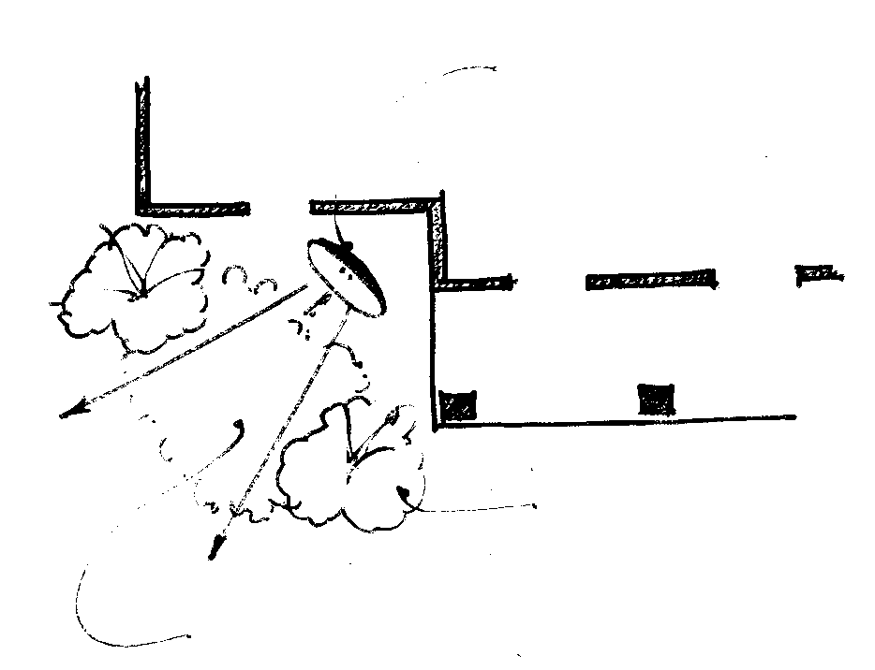
Satellite Dish House

Porch/Entry

signal

Tall screening
Height no shorter than the dish

Shorter landscaping as to not block signal

Satellite Dishes in the Front

Fig. 11

GUIDELINE NUMBER 14: Addresses

- Address plaque numbers that differ from the original installed by the builder are prohibited.

- No plants shall be planted in such a manner that such planting and their future growth obstruct view of the address plaque.
- Curb applied painted addresses are not allowed.

GUIDELINE NUMBER 15: SIGNS IN YARDS

- The ONLY sign allowed in the front or side yard for an unlimited period of time is a FOR SALE or FOR RENT sign or signs required by legal proceedings, in accordance with the Covenants.
- BOOSTER signs from schools or organizations are allowed to be displayed for a maximum period of two (2) consecutive weeks.
- CONTRACTOR signs to identify current work being done by contractor(s) are allowed to be displayed for a maximum period of two (2) consecutive weeks.
- POLITICAL signs may be displayed two weeks prior to an election and should be removed within twenty-four (24) hours of said election.
- Signs must not exceed 2 x 3 feet in size.

- Security signs as required by Governing Agencies are permissible.

GUIDELINE NUMBER 16: SPECIAL CONSIDERATION FOR LAKE LOTS

1. In addition to the above guidelines, all improvements to the rear yard shall be submitted for approval by the ARC. Improvements to rear yard within ten (10) feet of the rear property line are discouraged, and no structure will be approved that encroaches into common lake area.

GUIDELINE NUMBER 17: BUSINESS USE

- Each lot shall be used for residential purposes only, and no trade or business of any kind may be conducted in or from a Lot or any part of the Property, including business uses ancillary to a primary residential use, except that the Owner or Occupant residing in a dwelling on a Lot may conduct such ancillary business activities within the dwelling so long as…
  - The existence or operation of the business activity is not apparent or detectable by sight, sound, or smell from the exterior of the dwelling; and
  - The business activity conforms to all zoning requirements for the Property; and

  - The business activity does not increase traffic around the Property; and

  - The business activity does not increase the insurance premium paid by the Association or otherwise negatively affect the ability of the Association to obtain insurance coverage; and
  - The business activity is consistent with the residential character of the Property and does not constitute a nuisance or a hazardous or offensive use, or threaten the security or safety of other residents of the Property.
2. The terms “business” and “trade” as used in this provision, shall be construed to have their ordinary, generally accepted meanings, and shall include, without limitation, any occupation,
work, or activity undertaken on an ongoing basis which involves the provision of goods or services to persons other than the provider’s family and for which the provider receives a fee, compensation, or other form of consideration, regardless of whether: (i) such activity is engaged in full or part-time; (ii) such activity is intended to or does generate a profit; or (iii) a license is required thereof. Notwithstanding the above, the use of a Lot by an on-site management company operating on behalf of the Association shall not be considered a trade or business within the meaning of this subparagraph.

